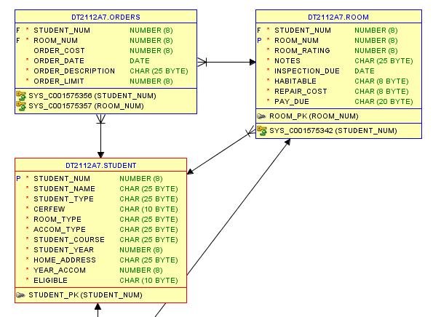For my individual databases assignment, I worked off the student residence tables that our group had created. In contrast to the group project, I struggled a lot more. Referring to part 1 and 2 I found not much issue with it as part 1 was simple, as it was simply granting myself permissions and part 2 had already been done in the group assignment.

I struggled a lot when it came to part 3 and didn’t get to flush out my transaction. I left the barebones of a statement which was an input statement as it was the most progress that I made on code that worked.

Part 4 was fairly easy as it just involved me looking over what the various statements did. I struggled with unions, minus and intersects and it can be seen reflected in the code but as for everything else they all functioned well. The inner and outer joins also functioned semi-well, showing different outputs for the different statements.